IT2120 - Probability and Statistics

Lab Sheet 10

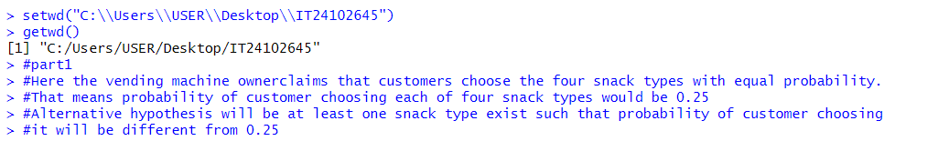 IT24102645

